Methodological recommendations for preparing for the boundary control on the topic "Endoscopy"

Question No. 1 Organization of the endoscopic service in Russia.
Endoscopic departments (offices) are organized in republican, regional, regional, city, central district hospitals, dispensaries and city polyclinics. The main task of the service is the use of endoscopic methods for the early diagnosis and treatment of diseases of the gastrointestinal tract, upper respiratory tract and bronchopulmonary apparatus. An endoscopic service is organized in a polyclinic if this institution serves 50,000 people or more. The endoscopic service is also organized in hospitals with 300 beds or more, and in dispensaries with 100 beds or more. If the hospital provides planned care, then the endoscopic department (office) should be close to the wards. If the hospital operates in an emergency medical system, the endoscopic department should be located as close as possible to the emergency room. The following premises should be provided in the structure of the department: Rooms for conducting research (gastroduodenoscopy, colonoscopy, bronchoscopy), washing and dysenfection of endoscopic equipment, storage room for endoscopic equipment, staff rooms, etc.
Question No. 2 Endoscope device
The endoscope consists of a controlled distal part (distal bent end), an inserted flexible tube, a block (control handle), a universal cord for connecting the endoscope to the base unit in which the light source is located, a gas and water supply system. The connector that connects the endoscope to the base unit is called a connector.
On the distal part (the head of the endoscope) there is an end window of the light guide (usually there are 2), an opening of the instrumental channel, a lens lens (in the case of a fibroendoscope) or a video camera (video endoscope), holes for air and water supply. The controls of the bendable part of the endoscope are located on the control unit. The large screw deflects the bent part in the vertical direction, the small screw in the horizontal direction. There are also two valves. The gas and water supply valve is located distally, and the aspiration valve is located proximally. The instrument channel of the endoscope opens in the distal part of the control handle.
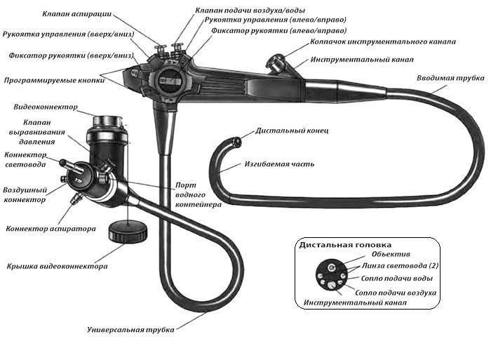
Question No. 3 Types of endoscopes and their purpose
Endoscopes are divided into rigid (rigid) and flexible. Rigid endoscopes are rarely used nowadays, and then only for the removal of foreign bodies. Flexible endoscopes, depending on the method of information transmission, are divided into fibroendoscopes – the image is transmitted via a flexible fiber and displayed on the eyepiece (the endoscopist looks with the eye) and a video endoscope - the image is displayed on the monitor screen.
Depending on the purpose, endoscopes are divided into:
An esophagogastroduodenoscope is a lens, channels and light guides are located at the end of the distal head. The thickness of the endoscope is about 1 cm (varies from manufacturer to manufacturer). The endoscope is designed to examine the esophagus, stomach, bulb of the duodenum and the postbulbar department of the duodenum.
Duodenoscope – the lens, channels and light guides are located at right angles to the axis of the endoscope (lateral location). There is a lift on the distal head for deflecting instruments inserted into the instrumental channel from the axis of the endoscope. A duodenoscope is somewhat thicker than an esophagogastroscope. It is designed to examine the duodenum and the large duodenal nipple. It is poorly suited for examining the esophagus and stomach.
A colonoscope is an endoscope for performing colonoscopy. A thicker and longer endoscope has an end arrangement of the lens, channels and light guides.

Question No. 4 Preparing the equipment for operation
High-level disinfection (TLD) and sterilization are used in the processing of endoscopic equipment.
The endoscope is processed using the TLD method, which provides for the removal of all vegetative forms of bacteria, fungi, viruses and a certain number of bacterial spores.
After each examination, the endoscope goes through the following processing steps:
Preliminary cleaning is performed in the endoscopy cabinet and consists in removing biological fluids from the surface of the endoscope and the instrumental canal and is aimed at preventing the drying of biological fluids on the surfaces of the endoscope.
Final cleaning is carried out in the endoscope processing room and consists in checking the endoscope for tightness, treatment in an antiseptic solution, treatment of the instrumental canal. At the end of the final cleaning, an azaperam test is performed for the presence of traces of biological fluids in the instrumental channel.
High–level disinfection is performed by immersing the endoscope in a solution intended for TLD (secusept, etc.)
Storage of the endoscope is carried out in a special cabinet that supports aseptic conditions.
Endoscopic instruments inserted into the instrumental canal must be sterile. Disposable instruments are in factory sterile packaging, reusable instruments are sterilized.

Question No. 5 Capsule endoscopy. The possibilities of the method.
Capsule endoscopy is mainly used as a method of diagnosing diseases of the small intestine. The fact is that the small intestine is like a "blind spot" that cannot be examined either with an esophagogastroduodenoscope or a colonoscope. Processes such as Crohn's disease, polyps, enteritis of various types, celiac disease, etc. are often located in the small intestine.
Special video capsules, sensing equipment systems, and data analysis programs have been developed for capsule endoscopy. The analysis of the results is carried out after an endoscopic examination. The patient is prepared as for a colonoscopy. Sensors of the recording device are mounted on the anterior abdominal wall at the recommended points. The patient then swallows the video capsule. At the same time, the patient lives and works as usual. After passing the capsule through the gastrointestinal tract, the doctor scans the resulting image.
The disadvantages of this method include its high cost.
Question No. 6 Endoscopic anatomy of the esophagus
The esophagus has a length of 20 to 34 cm and begins at 14-16 cm from the dentition. The esophagus ends with a passage into the stomach at the level of 28-41 cm. Its wall thickness is about 4 mm and the esophagus is lined with a multilayer flat non-corneating epithelium.
The esophagus has 4 anatomical constrictions:
The first constriction is the entrance to the esophagus. The muscular sphincter is located in this place and the pressure can reach 120 mmHg. During the act of swallowing, the sphincter relaxes and the pressure drops, which allows an endoscope to be performed.
The second narrowing is caused by the intersection of the esophagus with the aortic arch and the left main bronchus.
The third narrowing is the retrocardium of the esophagus. It is caused by the displacement of the anterior wall of the esophagus by the left ventricle of the heart. At this point, the esophagus has an oval cross-section and the pulsation of the heart is visible.
The fourth constriction is the lower esophageal constriction or cardia. This constriction is represented by the lower esophageal sphincter, at rest the pressure in this constriction is maintained at 15-25 mmHg. This sphincter is about 3 cm long, it begins above the diaphragm and ends below the diaphragm. From the side of the esophageal lumen, this narrowing looks like a folded constriction and is called a "cardia rosette". Below is the so-called Z-line, which is caused by the transition of the flat esophageal epithelium into the cylindrical gastric one.

Question No. 7 Endoscopic anatomy of the stomach and duodenum
The stomach is a hollow organ lined with cylindrical epithelium and having a thickness of about 8 mm. The following sections of the stomach are distinguished: the arch of the stomach (bottom of the stomach), the body of the stomach, the antrum, which passes into the pylorus. Also, in endoscopy, the precardial zone is 2 cm around the cardia and the prepiloric zone is 2 cm around the pylorus. The boundary of the transition of the stomach body to the antrum by a small curvature is the angle of the stomach. The anterior and posterior walls of the stomach and large and small curvature are also distinguished. The gatekeeper is visualized as a narrowing of various diameters (depending on the functional state) of a rounded shape. Following the gatekeeper, the bulb of the WPC begins and is visualized as an extension of the lumen of the WPC. Then the bulb passes into the postbulbar section, which has a transverse folding.

Question No. 8 Indications and contraindications for endoscopy. Emergency endoscopy.
The indications for endoscopy are extensive. The study is conducted to confirm or exclude the diagnosis in the presence of symptoms of a disease of the gastrointestinal tract, as well as in order to control existing disorders.
Contraindications for endoscopic examination are divided into absolute and relative. There is only one absolute contraindication – the lack of consent for the study on the part of the patient. Relative contraindications include decompensated pathology of the cardiopulmonary system, perforation of a hollow organ, terminal conditions of the patient.
Emergency endoscopy is indicated in the following cases: bleeding from the upper gastrointestinal tract, introoperative endoscopy, foreign bodies of the gastrointestinal tract.

Question No. 9 Preparing patients for endoscopy
No preparation is required for fibrogastroduodenoscopy as such. If FGDS is scheduled for the morning, then the day before from 18 o'clock the patient is forbidden to take food, and from 00 o'clock and liquids. If the patient suffers from chronic diseases and takes medications in the morning, then the patient is allowed to take the necessary medications and drink one or two sips of water. Before carrying out a planned FGD, after clarifying the allergic history, the patient is asked to perform anesthesia of the oropharynx with a 10% lidocaine solution in an aerosol. The decision to perform anesthesia is made by the patient and gives his consent. In the case of anesthesia after the examination, the patient is forbidden to eat and drink for 30 minutes in order to prevent aspiration. In case of emergency FGDS, anesthesia of the oropharynx is contraindicated.
If the patient is supposed to undergo endoscopic surgery (endoscopic polypectomy, dissection in the submucosal layer, etc.), then the patient is examined as before planned surgery. Premedication is prescribed to such patients in 30 minutes. If the study is supposed to be under anesthesia, then it is necessary to perform an ECG and have a therapist's opinion.
The preparation of the large intestine for endoscopic examination is described in question No. 23.
Question No. 10 Barrett's esophagus
In 1950, British surgeon Norman Barrett reported the presence of a cylindrical gastric epithelium in the distal part of the esophagus next to esophageal ulcers caused by gastroesophageal reflux. Thus, Barrett's esophagus is a condition in which, as a result of gastroesophageal reflux, foci of metaplasia of the gastric, small intestine or (which is rare) large intestinal epithelium appear in the distal part of the esophagus. The endoscopic image resembles pockets of flame rising from the Z-line upwards. One can talk about Barrett's esophagus if the foci of metaplasia spread upwards by more than 3 cm. In this case, a biopsy is indicated for histological and cytological examination.
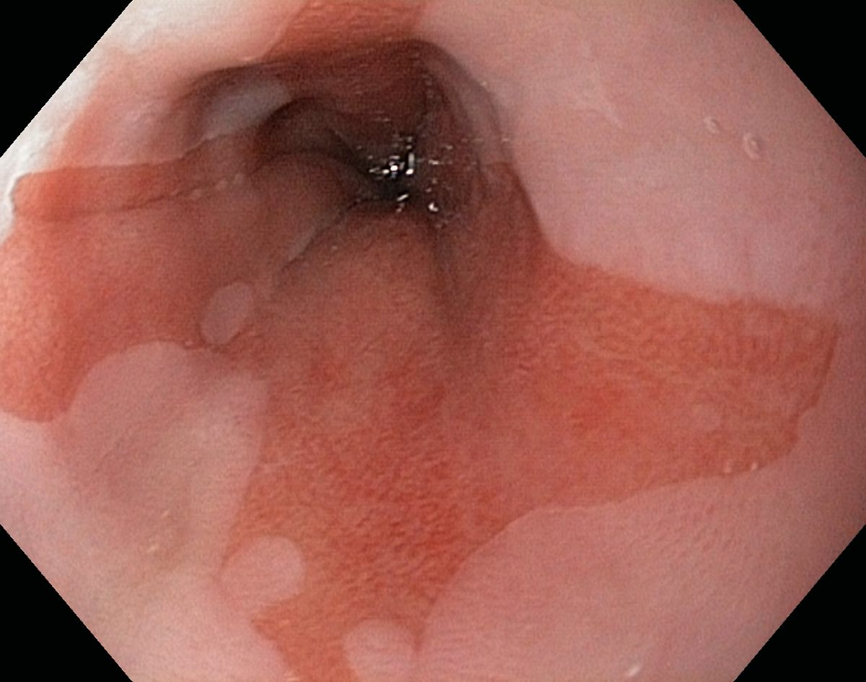
Tactics for Barrett's esophagus depend on the degree of dysplasia. In the absence or not a high degree of dysplasia, dynamic observation is indicated, with a high degree of dysplasia, surgical treatment is indicated, since such a condition is an obligate precancer.
Photo No. 1
Barrett's esophagus
Question No. 11 Endoscopic signs of axial hernia of the esophageal orifice of the diaphragm
A hernia of the esophageal orifice of the diaphragm should be understood as a permanent or periodic displacement of part of the stomach through the esophageal orifice of the diaphragm into the chest.

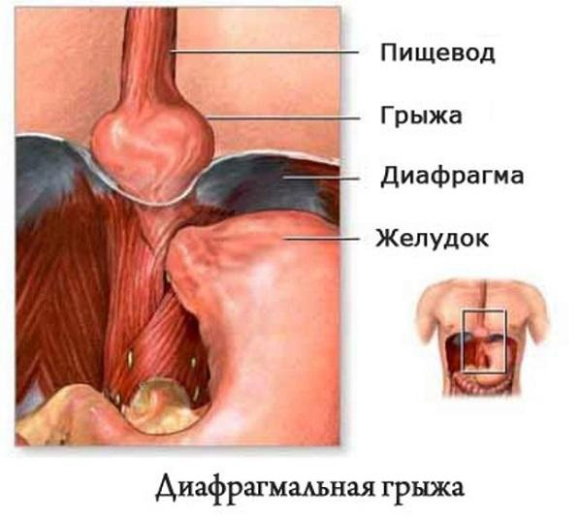
Fig.2 Axial hernia of the esophageal orifice of the diaphragm
The endoscopic signs of an axial hernia are:
During orthograde examination – the presence of a hernial cavity, the presence of a hiatal (diaphragmatic) constriction of the contracting respiration, the presence of gastric folds in the hernia cavity, gastric prolapse.
During retrograde examination: the cardia does not tightly "wrap around" the endoscope, there is a bell-shaped expansion above the chiatal constriction, the folds of the stomach "go up" (into the hernial cavity), the hernia retracts upwards when inhaled.
Question No. 12 Endoscopic signs of gastroesophageal reflux
Gastroesophageal reflux disease (GERD) is the most common cause of distal esophagitis. Esophagitis can also be triggered by alcohol intake, improper diet, esophageal injuries, radiation damage. Endoscopic signs of GERD are: hyperemia and edema of the mucous membrane of the esophagus, the presence of erosions. According to the Los Angeles classification, there are:
Stage A-hyperemia and single erosions in the lower third of the esophagus at the tops of folds up to 5mm. Stage B – hyperemia and erosion in the distal part of the esophagus more than 5 mm. Stage C is drainage erosion, occupying up to 75% of the circumference of the esophagus. Stage D- drainage erosions that occupy more than 75% of the circumference of the esophagus.

Question No. 13 Acute gastritis. The endoscopic picture.
Gastritis, both acute and chronic, is a reaction of the gastric mucosa to various irritating substances. Acute and chronic gastritis are absolutely not similar to each other, not in the clinical picture, not in the endoscopic and are not stages of the same process. Acute gastritis can be caused by both exogenous and endogenous irritants. The causes of acute gastritis are: infections (H. pilory), medications, duodenogastric reflux, intoxication (alcohol), etc. The endoscopic picture is vitreous edema and hyperemia of the mucous membrane, the presence of erosions (more often in the antrum), submucosal hemorrhages.

Question No. 14 Chronic gastritis. The endoscopic picture.
There are three forms of chronic gastritis. Atrophic, hyperplastic and mixed (atrophic-hyperplastic).
In atrophic gastritis, dystrophic and dysregenerative changes lead to a decrease in the number of gastric glands. The endoscopic picture of atrophic gastritis is a thinning of the mucous membrane (blood vessels located in the submucosal layer are visible), a decrease in gastric folds. In hyperplastic gastritis, immune processes predominate, manifested by lymphoplasmocytic infiltration. Endoscopically, prosoid rashes of whitish color are detected, against the background of a more pronounced color of the mucous membrane. There may be chronic erosion in the antrum.
Question No. 15 Acute and chronic gastric erosion. The endoscopic picture.
Acute erosion is called a superficial violation of the integrity of the gastric mucosa, spreading no deeper than the muscular plate of the mucous membrane. This is a flat, irregularly shaped defect in which inclusions of hematin or fibrin may be present. Since the deeper layers are not damaged, acute erosion heals without a trace.
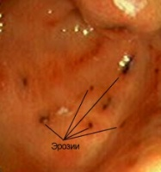
Photo No. 2 Acute erosion

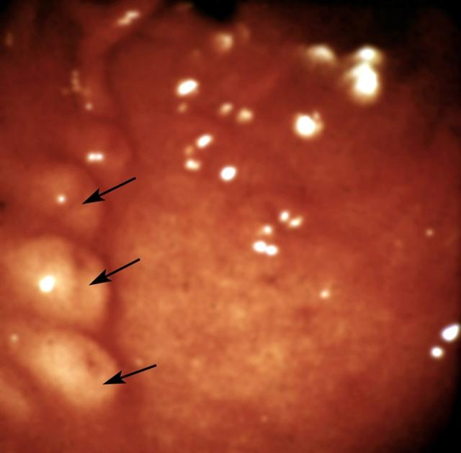
Chronic erosion (papule) is an elevated formation on a wide base measuring no more than 5 mm. They are arranged in chains on the tops of the folds, usually in the antrum of the stomach. The morphological substrate of the papule is granulomatous tissue, lymphocytic infiltration. During the period of its existence, papules go through several stages - hemorrhagic, aphthous, umbilical, simple. Chronic erosion heals without a trace. The presence of a single erosion is an indication for a biopsy.

Photo No. 3 Chain of chronic erosions (papules)

Question No. 16 Acute gastric ulcer and duodenal ulcer. The endoscopic picture.
An acute ulcer is a defect of the gastric mucosa or duodenum, deep to the muscle layer. The causes of acute ulcers can be – taking NSAIDs, hormonal drugs, stress, etc. Acute ulcers can be located in any part of the stomach. Thus, acute ulcers with prolonged use of NSAIDs are more often located in the antrum, the favorite localization of stress ulcers, cardiogenic ulcers is the body and the arch of the stomach. In appearance, an acute ulcer is a flat, irregularly shaped defect covered with fibrin, often there are inclusions of hematin, since acute ulcers often cause bleeding. An acute ulcer heals with the formation of a linear scar and does not lead to deformation of the organ.

Question No. 17 Chronic gastric ulcer and duodenal ulcer. The endoscopic picture. Stages of healing.
Chronic gastric ulcer or DPC (morphological substrate of peptic ulcer disease) is a deep destructive process in the wall of the stomach or DPC, penetrating deeper than the muscle layer. Such ulcers often have complications in the form of perforation, bleeding, and deformation of the organ during scarring. The endoscopic picture is represented by a deep crater-shaped defect, the edges around the defect are raised by a zone of perifocal inflammation. Folds converge to the ulcerative defect, there is a gross deformation of the organ with a possible violation of evacuation. There are several stages in the healing of a chronic ulcer. The stage of the red scar (the scar is represented by granulation tissue) and the stage of the white scar. The white scar has an irregular stellate shape. With an exacerbation of peptic ulcer disease, a new defect usually occurs with the seizure of the white scar area.

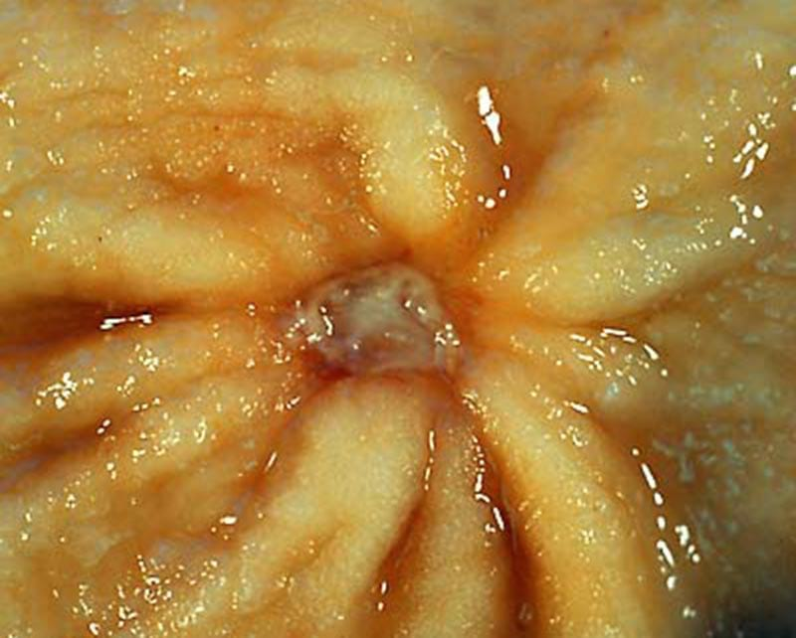
Photo No. 4 Chronic stomach ulcer
Question No. 18 Gastroduodenal bleeding of ulcerative etiology.
Bleeding from stomach ulcers or duodenal ulcers occurs due to the arrosion of a blood vessel located at the bottom of an ulcerative defect. Bleeding can be venous and arterial, and vary in intensity – from small, non-clinically manifested hemorrhages to profuse arterial jets accompanied by hypovolemic shock. The following symptoms suggest the presence of gastroduodenal bleeding: vomiting of the "coffee grounds" type, black fecal coloration, decreased red blood counts, violation of central hemodynamics. If bleeding from the upper gastrointestinal tract is suspected, emergency FGDS is indicated, which allows you to solve the following tasks: identify the presence or absence of bleeding, identify its causes, assess the state of hemostasis, stop bleeding or prevent its recurrence.
Question No. 19 Endoscopic classification of Forrest. Tactics of endoscopic hemostasis.
The Forrest classification describes the state of hemostasis in the area of a mucosal defect.
F-I (ongoing bleeding)
F-Ia- ongoing arterial bleeding
F-Ib- ongoing venous bleeding
F-II (stopped bleeding)
F-IIa- a thrombosed vessel is visible
F-IIb- a blood clot covers a wall defect
F-IIc is hematin in the ulcerative defect.
F-III – there are no endoscopic signs of bleeding.
In Forrest I, endoscopic bleeding arrest is indicated, in Forrest II– endoscopic prevention of bleeding recurrence is indicated.
Question No. 20 Methods of endoscopic hemostasis and their characteristics.
Methods of endoscopic hemostasis include:
Application therapy is the application of various adhesive compositions, fibrin films, etc. to the surface of the ulcer. It is rarely used.
Injection therapy is the pricking of an ulcer with the introduction of solutions. It is possible to introduce a solution of adrenaline, aminocaproic acid, or saline solution. The effect of injection therapy is twofold - the creation of a "cushion" leads to mechanical compression of the vessel. When adrenaline is added, the vessel spasms, which leads to a decrease in its diameter. Injectable hemostasis is one of the most reliable and frequently used methods.
Thermal methods – monopolar and bipolar coagulation, diathermocoagulation, argon plasma coagulation. The method is based on brewing a bleeding vessel.
Mechanical hemostasis is hemoclyping. Applying special endoscopic clips to the vessel.
To stop and prevent bleeding, it is necessary to use a combination of at least two of the above methods.

Question No. 21 Complications of endoscopy
Complications of endoscopy are quite rare. The overall complication rate does not exceed 0.1%, and the mortality rate is less than 0.01%. The most frequent complications are observed from the cardiovascular and pulmonary systems (1/2000 studies and 1/4000 studies, respectively). Perforations of hollow organs, bleeding, and infectious complications are even less common. There are also complications that are not related to the technical aspects of endoscopic examination. Such complications include: complications during local anesthesia of the oropharynx (allergic reactions, aspiration), complications associated with taking drugs that cause watery diarrhea during the preparation of the large intestine in colonoscopy.

Question No. 22 Stomach polyps. Endoscopic polypectomy.
Polyps are understood to be benign tumors of epithelial origin protruding into the lumen of the stomach. Among them, adenomatous polyps are distinguished - true epithelial polyps and hyperplastic polyps, which are classified as pseudopolypes.
Adenomatous polyps develop as a result of dysregenerative processes in the epithelium, leading to focal hyperplasia of the superficial epithelium.
Hyperplastic polyps are observed 16 times more often, develop against the background of atrophic gastritis. These polyps develop due to an increase in cell lifespan, which leads to excessive regeneration. Hyperplastic polyps can regress.
Complications of polyps may include malignancy (most often adenomatous polyps), ulceration with bleeding, and impaired evacuation.
When a polyp is detected, the doctor is obliged to take a biopsy and send the material for histological and cytological examination, since it is necessary to carry out a differential diagnosis between the polyp and the polypoid form of early gastric cancer.
Endoscopic polypectomy technique: the patient is prepared as for planned surgical treatment, premedication is prescribed. After visualization of the polyp, lifting is performed by injecting saline solution with adrenaline in a dilution of 1/10000 into the base of the polyp (1 ml of 0.1% adrenaline solution is diluted with 10 ml of saline solution). It is also recommended to add a dye (indigocarmine) to the solution to visualize the base of the polyp. After that, a diathermic loop is placed on the polyp, inserted through the instrumental channel of the endoscope. Then the polyp is cut off by electrocoagulation in a mixed mode and extracted for histological examination.

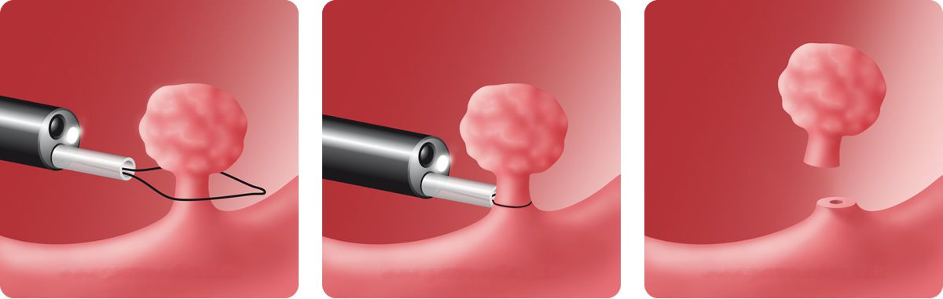
Fig. No. 3 Endoscopic polypectomy

Question No. 23 Preparation of the large intestine for endoscopic examination.
Currently, drugs that cause watery diarrhea are used to prepare the large intestine. There are drugs of hyperosmotic action – these are drugs containing salts and, due to the hyperosmotic concentration in the lumen of the large intestine, contribute to the attraction of fluid into its lumen ("Kolokit", "Eziklen"). There are also drugs of isoosmotic action. These include preparations containing polyethylene glycol (PEG). Its important characteristic is that it is not absorbed into the patient's body (Fortrans, Moviprep).
The two-component regimen of the drug is the most optimal for preparing the large intestine for examination. The first dose is taken the evening before the study, the second dose of the drug is taken in the morning on the day of the study. The morning dose is called a split dose.
The following is the scheme used in our clinic for the preparation of the large intestine.
3-4 days before the study, a diet is prescribed that excludes the intake of plant foods. It is recommended to take food of animal origin. For preparation, our clinic uses the drug "Moviprep", which combines PEG and a high concentration of ascarbic acid (to achieve a hyperosmotic effect). The first dose of the drug is taken the night before at 18 o'clock – 1 liter of the drug, which is washed down with 0.5 liters of clear liquid (water, weak tea, apple juice). A split dose of the drug is taken in the morning on the day of the study at 5-6 o'clock (but not earlier than 4 hours before the start of the study). The patient also drinks 1 liter of the drug and washes it down with 0.5 liters of clear liquid.
The preparation of the patient with enemas is carried out in patients with colostomy and it is necessary to examine the distal part of the large intestine.
Question No. 24 Screening colonoscopy.
Colon cancer is one of the most common localizations among malignant neoplasms of the gastrointestinal tract. The state is developing programs for the early detection of cancer and precancerous conditions (polyps), which can improve treatment results or prevent the development of the oncological process. The Ryazan region, along with other regions, is taking part in a pilot project on screening colonoscopy. This project includes patients aged 49 to 74 years old. Screening is carried out in 2 stages. When contacting the polyclinic, patients are tested for feces for hidden blood. If the test is positive, then such a patient is referred for a colonoscopy, which is performed after preliminary preparation. If early cancer is detected, such a patient is referred to an oncologist, and if polyps are detected, an endoscopic polypectomy is performed, which reduces the risk of developing the oncological process.

Question No. 25 Colon polyps
Polyps are small formations of different sizes on a wide base or thin stem. By analogy with gastric polyps, hyperplastic polyps and adenomatous polyps are distinguished. Single polyps are 3 times more common than multiple polyps, and the most common localization is the sigmoid colon. Polypous growths of the large intestine can develop against the background of chronic inflammatory diseases, however, there are polyps, the cause of which is considered to be a violation of embryogenesis, dysembrioplasia (familial polyposis of the colon). The main danger of polyps is that they can become malignified. Glandular polyps are malignified in 10%, and villous (multiple papillary growths of the mucous membrane) – in 50% of cases (S.A. Palevskaya, A.G. Korotkevich). A big problem is created by the fact that the malignancy of the polyp begins, as a rule, at its base. Thus, a biopsy taken from the tip of the polyp does not reflect its true histological and cytological picture. It should be noted that small polyp sizes (up to 5 mm) are more common than others and reach up to 45%. Polyps of this size are difficult to detect endoscopically. Modern endoscopic complexes make it possible to identify such small formations. For this purpose, functions such as zoom endoscopy and monochrome endoscopy are used.

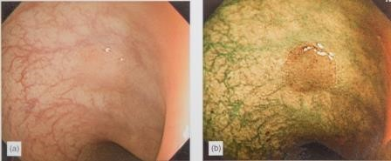
Photo No.5 Colon polyp (photo on the left in white light, photo on the right using the narrow-spectrum colonoscopy function).
Endoscopic removal of such polyps prevents malignancy and thus serves as cancer prevention.

Question No. 26 Colon cancer
According to WHO, about 500 thousand cases of colorectal cancer are registered annually in the world. The highest incidence was noted in the USA, Canada, Western European countries and Russia.
The clinical picture of colorectal cancer is quite diverse: from anemia when the tumor is located in the right parts, to intestinal obstruction when it is localized in the right parts of the large intestine. According to the endoscopic classification, exophytic forms and endophytic forms are distinguished (ulcerative form, diffuse-infiltrative form).
With the advent of modern endoscopic equipment that allows the use of chromoscopy (indigocarmine), Zoom endoscopy, narrow-spectral endoscopy, it became possible to examine the mucosal pattern on the surface of the formation. In 1996, the Japanese scientist S. Kudo, while examining about 2,500 patients, drew attention to the fact that each type of tumor has its own mucosal pattern. Based on this observation, he created the pit-pattern classification, which literally means the classification of "pits and depressions". Since then, the term "optical biopsy" has been introduced. According to this classification, there are 5 types with subtypes of the structure of the mucosa on the surface of the tumor. The structure of the mucosa type I, II - usually have formations of non-tumor etiology, type V corresponds to colon cancer. Depending on the type of dimple pattern, tactics for the treatment of such patients have been developed - from endoscopic polypectomy to radical surgical treatment.

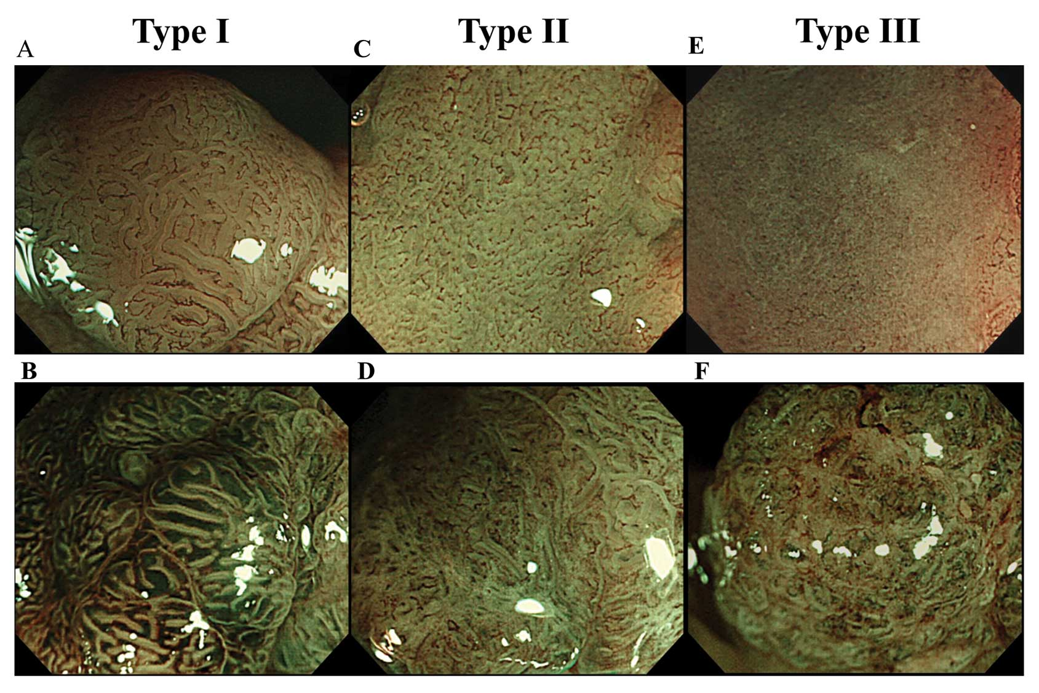
Photo No.6 Types of mucosal structure according to pit-pattern classification according to S. Kudo (2006)
Question No. 27 Endoscopic retrograde cholangiopancreatography (ERCP).
A method of diagnosis and surgical treatment of pathology of the main biliary tract and the main pancreatic duct. The essence of the method consists in bringing the duodenoscope to the large duodenal juice (BDS), dissecting it (papillotomy), catheterization of the choledochus or virsung duct. Then a water-soluble iodine-containing contrast (Omnipack, Trazograph) is injected into the ducts and X-rays are taken, which can reveal the thickness of the duct, the presence of additional formations in it (concretion, cancer, stricture). With the help of the inserted tool (Dormia basket), it is possible to extract concretions into the lumen of the duodenum. The availability of modern equipment makes it possible to perform stenting of the biliary tract and the main pancreatic duct.
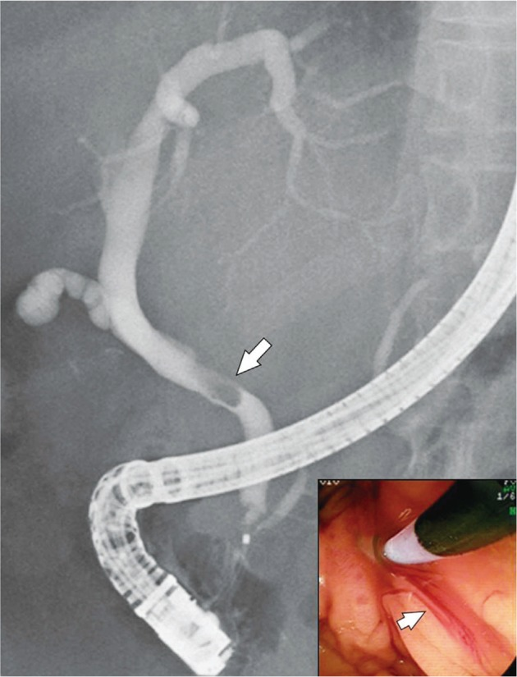
Photo No. 7 of the ERCP (the arrow indicates a concretion in the common bile duct)
Question No. 28 of the endowment. The possibilities of the method.
Endoscopic ultrasound examination (ENDOUSSI) is a unique method of endoscopic diagnosis, during which an intraluminal ultrasound scan of the walls of the organ under study, as well as anatomical structures and tissues adjacent to these organs, is performed. Endoussis is the only method of visualizing the layers of the wall of the esophagus, stomach, and duodenum. The examination is performed using a special endoscope, at the end of which there is a miniature ultrasonic sensor. This method allows to determine the depth of tumor germination of the organ wall, to identify metastatic lesion of regional lymph nodes. In early cancer (a malignant process that does not penetrate deeper than the submucosal layer), this method allows you to determine the possibilities of endoscopic removal of the tumor. Performing endoussis before and after chemoradiotherapy allows you to evaluate the treatment performed.

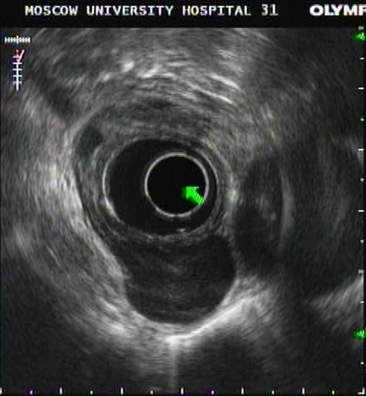
Photo No.8 Endo- ultrasound examination. Leiomyoma of the lower thoracic esophagus with a predominantly extraorgan location.

Question No. 29 Foreign bodies of the gastrointestinal tract.
These are items that entered the organs of the digestive tract from the outside or were formed in the body itself and, by their composition, cannot be used as food. Foreign bodies of the gastrointestinal tract can be different in nature and origin. The frequency of endoscopic interventions for foreign bodies of the gastrointestinal tract can reach up to 70%, with the success rate of extraction up to 94-96%. The presence of clinical signs of perforation of a hollow organ (mediasthenitis with perforation of the esophagus, peritonitis with perforation of the stomach and duodenum) is a contraindication for endoscopy - these conditions require surgical intervention and endoscopy should not delay it. Surgical intervention is also indicated in the case of a foreign body distal to the duodenum, if migration does not occur for more than 1 week.
Indications for endoscopy can be divided into the following groups:
Emergency endoscopy – patients with esophageal obstruction with inability to swallow and pain, disc batteries in the esophagus, sharp objects in the esophagus
Urgent endoscopy – Foreign bodies of the esophagus that do not have sharp edges or ends and without complete obstruction. Sharp objects in the stomach and the duodenum.
Delayed endoscopy - objects up to 2.5 cm in the stomach, coins in the esophagus in the absence of symptoms.
Nevertheless, it should be noted that in the presence of a 24-hour endoscopic service, an attempt to extract a foreign body should be made as quickly as possible.
During endoscopic removal, the foreign body can be crushed, captured by a loop or special tools and extracted outside.

Question No. 30 Bleeding from varicose veins of the esophagus.
Varicose veins of the esophagus are a typical manifestation of portal hypertension. Bleeding from dilated veins of the esophagus and stomach is also considered severe: mortality at the first bleeding reaches 50-70%, another 30% die from a recurrence of bleeding. It was found that during the first 2 years from the moment of the first episode of bleeding, it repeats in all patients.
The presence of a clinical picture of bleeding from the upper gastrointestinal tract in the patient is an indication for emergency GDS. When determining the fact of bleeding from varicose veins of the esophagus, endoscopic hemostasis is not performed in our clinic. All attempts to perform it in most cases led to increased bleeding or its recurrence. However, there are methods for injecting sclerants (Ethoxysclerol) into a vein proximal to the bleeding node. The presence of ongoing bleeding from the veins of the esophagus is an indication for the installation of a Blackmore probe.
After the patient is stabilized and stable hemostasis is achieved, either endoscopic ligation of varicose nodes or endoscopic application of latex rings is performed.

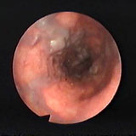
Photo No. 9 Varicose veins of the lower thoracic esophagus.

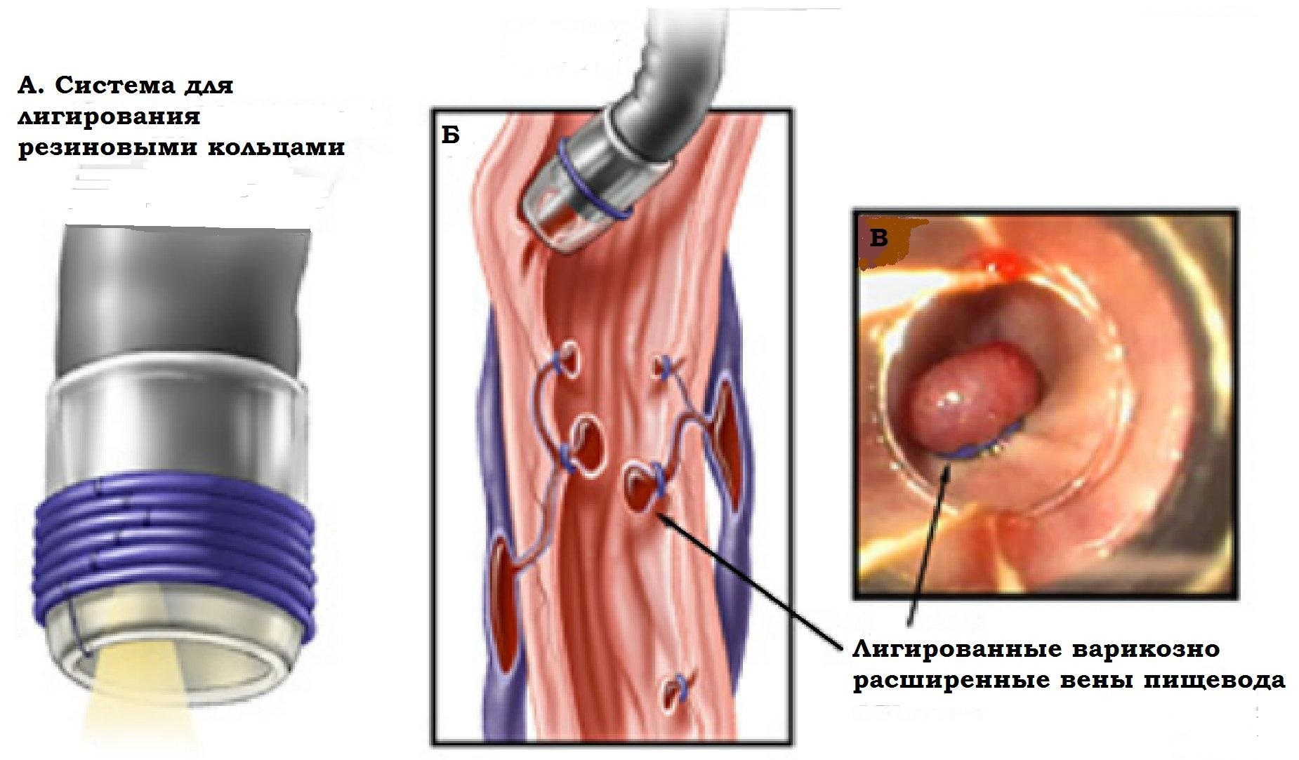
Fig. No. 4 Latex ring ligation system.
Question No. 31 Surgical endoscopy. Endoscopic mucosal resection.
Endoscopic mucosal resection (ERS) is a minimally invasive organ-preserving operation that involves resection of the mucous membrane through an endoscope. ERS is indicated for the removal of polyps and early forms of cancer without deep invasion. The following conditions are required to fulfill the ERS:
- the tumor was detected at an early stage;
- the process is limited by the mucous membrane (according to endo- ultrasound examination);
- the size of the neoplasm is not more than 20 mm;
- there are no metastases to the lymph nodes;
- there are no ulcers and scars of the mucous membrane.
The technique of execution is as follows. The preparation of the patient is carried out as for planned surgical treatment. After staining the affected area of the mucous membrane, the boundaries of the resection are marked with a coagulator. Then, the neoplasm is lifted by injecting a liquid into the submucosal layer (saline solution with adrenaline, hyaluronic acid). Due to this, the mucous membrane is lifted and the risk of organ perforation is reduced. Then, with power tools (diathermic loop, knives for mucosal resection), its resection is performed. After hemostasis control, the operation ends and the patient is transported to the ward for dynamic observation.

Question No. 32 Surgical endoscopy. Dissection in the submucosal layer and tunneling operations.
Very often, tumors located in the submucosal layer (gastrointestinal stromal tumors - GISO, lipomas, etc.) are found in the gastrointestinal tract. Modern endoscopic equipment allows the removal of such formations. The technique and preparation of the patient is similar to ERS, except that the manipulation is performed deeper than the mucous membrane and is more difficult to perform.
Tunnel operations were developed as an element of transorgan operations with a high risk of perforation of the hollow organ. Indications for such operations are deep–lying submucosal tumors and a high risk of perforation of the hollow organ during surgery, achalasia of the esophagus - oral endoscomic myotomy (POEM).
The essence of this operation is that the incision of the mucosa is performed proximally 4-6 cm from the removed formation. With the help of hydraulic preparation and power tools, a tunnel is created into which an endoscope is inserted. Through this tunnel, the formation or dissection of the cardiac sphincter is performed (in case of esophageal achalasia). After hemostasis control, the operation ends with clipping of the dissected mucosa. In the case of perforation of a hollow organ, the tunnel avoids the ingress of its contents into the abdominal cavity or into the mediastinum.

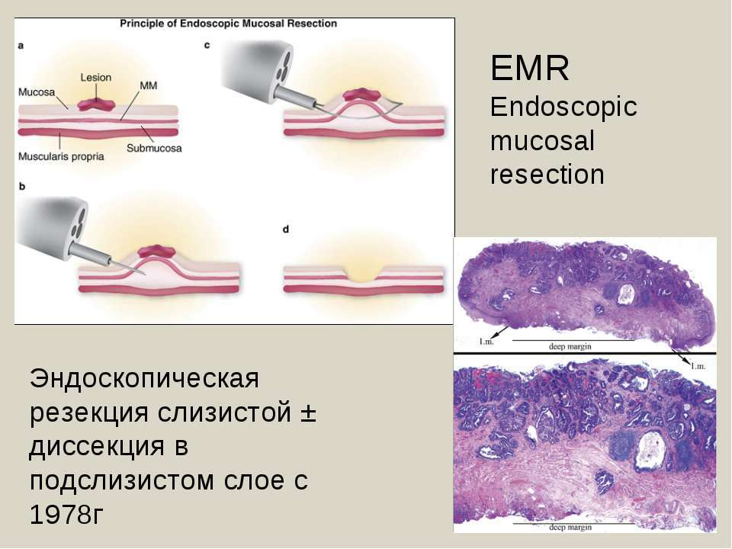
Fig. No. 5 Scheme of endoscopic resection of the mucous membrane

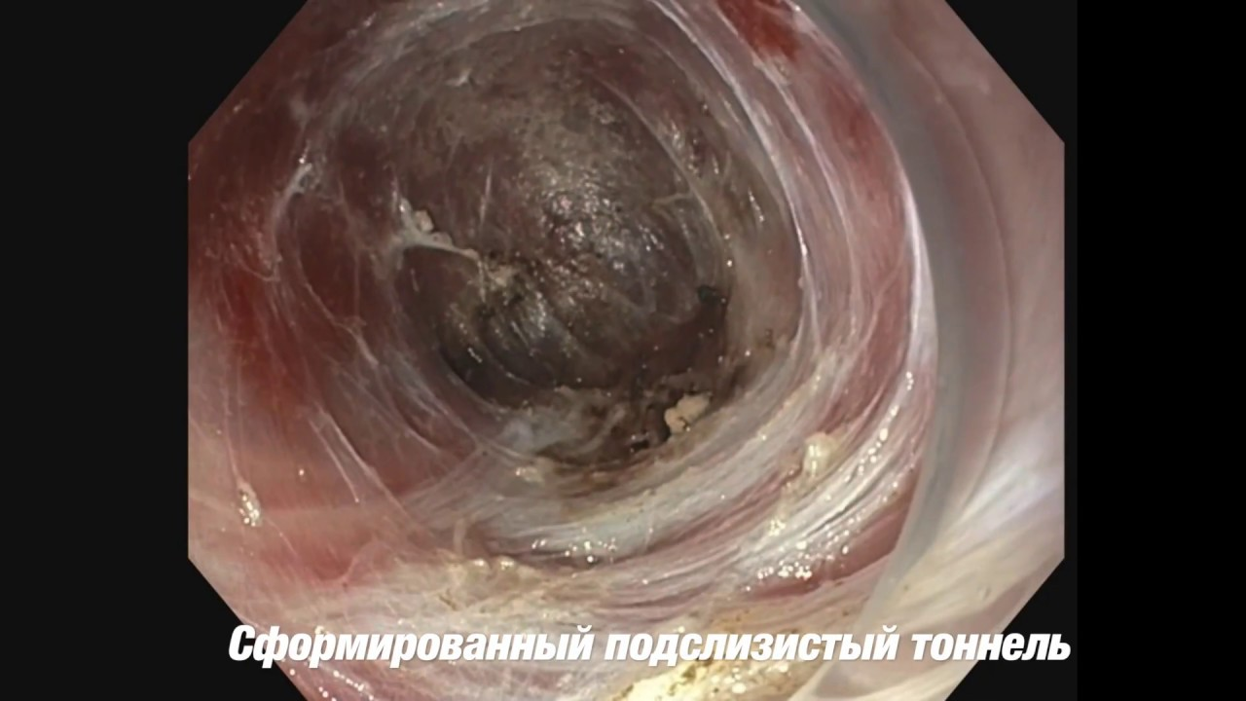
Photo No. 10 Tunnel formed in the submucosal layer during oral endoscopic myotomy for esophageal achalasia.

